Q 1 Write a query that uses a subquery to obtain all orders for the customer named Cisneros. Assume you dont know his customer number.

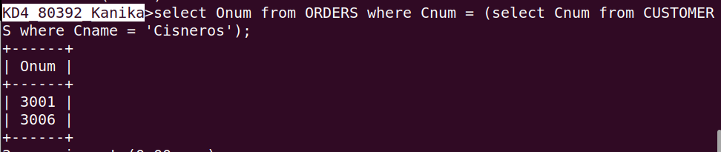

Q 2 write a query that produces the names and ratings of all customers who have above – average orders.

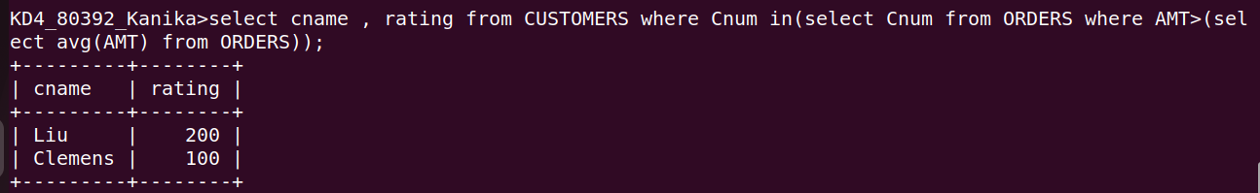

Q 3 Write a query that selects the total amount in orders for each salesperson for whom this total is greater than the amount of the largest order in the table.
